1. Create the following tables:
Table name: CLIENT_MASTER
Column Name | Data Type | Size | Attributes
CLIENTNO | Varchar | 6 | Primary Key / First letter must start with ‘C’
NAME | Varchar | 20 | Not Null
CITY | Varchar | 15
PINCODE | Number | 8
STATE | Varchar | 15
BALDUE | Number | 10,2

Table_Name: PRODUCT_MASTER
Column Name | Data Type | Size | Attributes
PRODUCTNO | Varchar | 6 | Primary Key / First letter must start with ‘P’
DESCRIPTION | Varchar | 15 | Not Null
PROFITPERCENT | Number | 4,2 | Not Null
UNITMEASURE | Varchar | 10 | Not Null
QTYONHAND | Number | 8 | Not Null
REORDERLVL | Number | 8 | Not Null
SELLPRICE | Number | 8,2 | Not Null, cannot be 0
COSTPRICE | Number | 8,2 | Not Null, cannot be 0

Table_Name: SALESMAN_MASTER
Column Name | Data Type | Size | Attributes
SALESMANNO | Varchar | 6 | Primary Key / First letter must start with ‘S’
SALESMANNAME | Varchar | 20 | Not Null
ADDRESS1 | Varchar | 30 | Not Null
ADDRESS2 | Varchar | 30
CITY | Varchar | 20
PINCODE | Number | 8
STATE | Varchar | 20
SALAMT | Number | 8,2 | Not Null, cannot be 0
TGTTOGET | Number | 6,2 | Not Null, cannot be 0
YTDSALES | Number | 6,2 | Not Null
REMARKS | Varchar | 60

Table_Name: SALES_ORDER
Column Name | Data Type | Size | Attributes
ORDERNO | Varchar | 6 | Primary Key / First letter must start with ‘O’
CLIENTNO | Varchar | 6 | Foreign Key references ClientNo of Client_Master table
ORDERDATE | Date |  | Not Null
DELYADDR | Varchar | 25
SALESMANNO | Varchar | 6 | Foreign Key references SalesmanNo of Salesman_Master table
DELYTYPE | Char | 1
BILLYN | Char | 1
DELYDATE | Date
ORDERSTATUS | Varchar | 10

Table_Name: SALES_ORDER_DETAILS
Column Name | Data Type | Size | Attributes
ORDERNO | Varchar | 6 | Foreign Key references OrderNo of Sales_Order table
PRODUCTNO | Varchar | 6 | Foreign Key references ProductNo of Product_Master table
QTYORDERED | Number | 8
QTYDISP | Number | 8
PRODUCTRATE | Number | 10,2

CREATE TABLE CLIENT_MASTER (
CLIENTNO VARCHAR(6) PRIMARY KEY,
NAME VARCHAR(20) NOT NULL,
CITY VARCHAR(15),
PINCODE INT,
STATE VARCHAR(15),
BALDUE DECIMAL(10,2),
CONSTRAINT chk_clientno CHECK (CLIENTNO LIKE 'C%')
);

CREATE TABLE PRODUCT_MASTER (
PRODUCTNO VARCHAR(6) PRIMARY KEY,
DESCRIPTION VARCHAR(15) NOT NULL,
PROFITPERCENT DECIMAL(4,2) NOT NULL,
UNITMEASURE VARCHAR(10) NOT NULL,
QTYONHAND INT NOT NULL,
REORDERLVL INT NOT NULL,
SELLPRICE DECIMAL(8,2) NOT NULL,
COSTPRICE DECIMAL(8,2) NOT NULL,
CONSTRAINT chk_productno CHECK (PRODUCTNO LIKE 'P%'),
CONSTRAINT chk_sellprice CHECK (SELLPRICE <> 0),
CONSTRAINT chk_costprice CHECK (COSTPRICE <> 0)
);

CREATE TABLE SALESMAN_MASTER (
SALESMANNO VARCHAR(6) PRIMARY KEY,
SALESMANNAME VARCHAR(20) NOT NULL,
ADDRESS1 VARCHAR(30) NOT NULL,
ADDRESS2 VARCHAR(30),
CITY VARCHAR(20),
PINCODE INT,
STATE VARCHAR(20),
SALAMT DECIMAL(8,2) NOT NULL,
TGTTOGET DECIMAL(6,2) NOT NULL,
YTDSALES DECIMAL(6,2) NOT NULL,
REMARKS VARCHAR(60),
CONSTRAINT chk_salesmanno CHECK (SALESMANNO LIKE 'S%'),
CONSTRAINT chk_salamt CHECK (SALAMT <> 0),
CONSTRAINT chk_tgttoget CHECK (TGTTOGET<> 0)
);

CREATE TABLE SALES_ORDER (
ORDERNO VARCHAR(6) PRIMARY KEY,
CLIENTNO VARCHAR(6),
ORDERDATE DATE NOT NULL,
DELYADDR VARCHAR(25),
SALESMANNO VARCHAR(6),
DELYTYPE CHAR(1),
BILLYN CHAR(1),
DELYDATE DATE,
ORDERSTATUS VARCHAR(10),
CONSTRAINT chk_orderno CHECK (ORDERNO LIKE 'O%'),
CONSTRAINT fk_clientno FOREIGN KEY (CLIENTNO) REFERENCES CLIENT_MASTER(CLIENTNO),
CONSTRAINT fk_salesmanno FOREIGN KEY (SALESMANNO) REFERENCES SALESMAN_MASTER(SALESMANNO)
);

CREATE TABLE SALES_ORDER_DETAILS (
ORDERNO VARCHAR(6),
PRODUCTNO VARCHAR(6),
QTYORDERED INT,
QTYDISP INT,
PRODUCTRATE DECIMAL(10,2),
PRIMARY KEY (ORDERNO, PRODUCTNO),
CONSTRAINT fk_orderno FOREIGN KEY (ORDERNO) REFERENCES SALES_ORDER(ORDERNO),
CONSTRAINT fk_productno FOREIGN KEY (PRODUCTNO) REFERENCES PRODUCT_MASTER(PRODUCTNO)
);

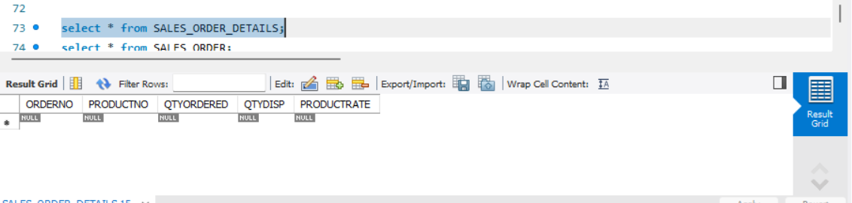

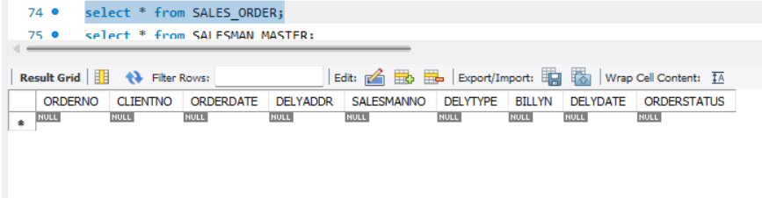

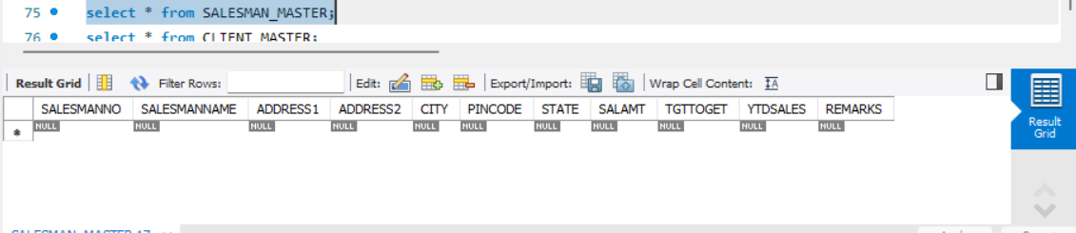

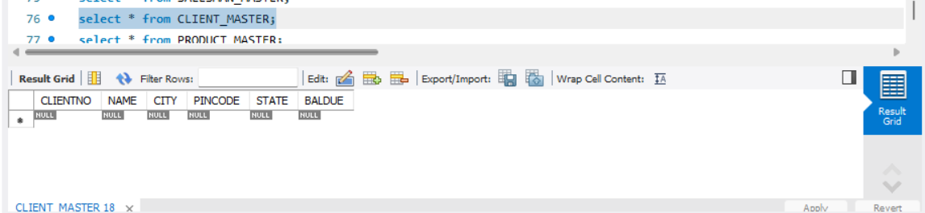

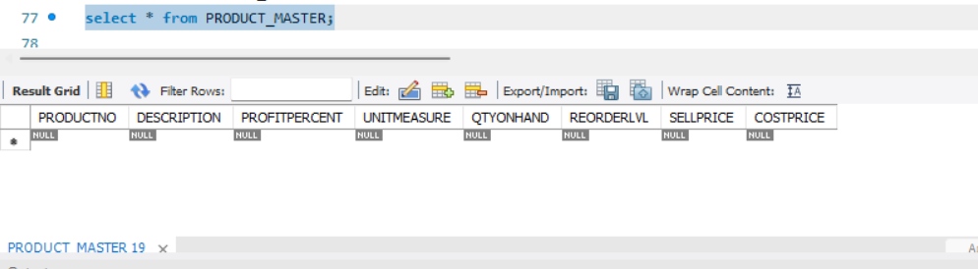

2. Insert the following data into their respective tables:

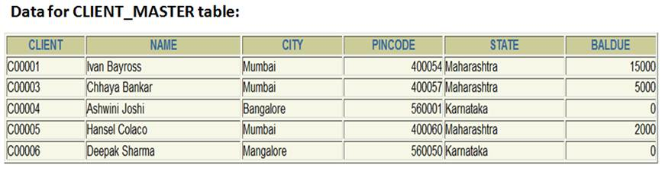

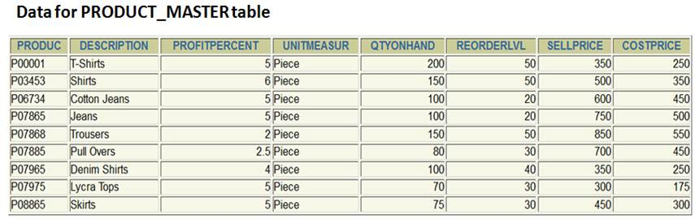

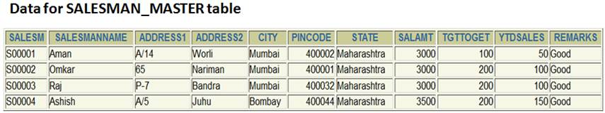
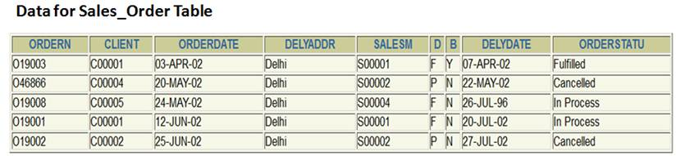

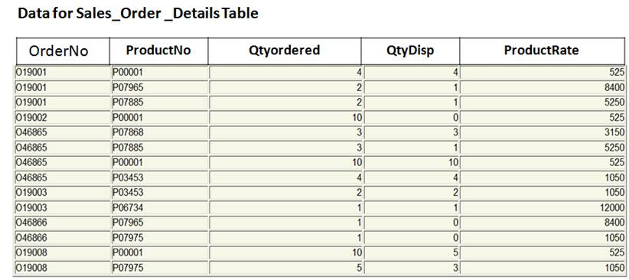

INSERT INTO CLIENT_MASTER (CLIENTNO, NAME, CITY, PINCODE, STATE, BALDUE) VALUES
('C00001', 'Ivan Bayross', 'Mumbai', 400054, 'Maharashtra', 15000.00),
('C00003', 'Chhaya Bankar', 'Mumbai', 400057, 'Maharashtra', 5000.00),
('C00004', 'Ashwini Joshi', 'Bangalore', 560001, 'Karnataka', 0.00),
('C00005', 'Hansel Colaco', 'Mumbai', 400060, 'Maharashtra', 2000.00),
('C00006', 'Deepak Sharma', 'Mangalore', 560050, 'Karnataka', 0.00);

INSERT INTO PRODUCT_MASTER
(PRODUCTNO, DESCRIPTION, PROFITPERCENT, UNITMEASURE, QTYONHAND, REORDERLVL, SELLPRICE, COSTPRICE)
VALUES
('P00001', 'T-Shirts', 5.00, 'Piece', 200, 50, 350.00, 250.00),
('P03453', 'Shirts', 6.00, 'Piece', 150, 50, 500.00, 350.00),
('P06734', 'Cotton Jeans', 5.00, 'Piece', 100, 20, 600.00, 450.00),
('P07865', 'Jeans', 5.00, 'Piece', 100, 20, 750.00, 500.00),
('P07868', 'Trousers', 2.00, 'Piece', 150, 50, 850.00, 550.00),
('P07885', 'Pull Overs', 2.50, 'Piece', 80, 30, 700.00, 450.00),
('P07965', 'Denim Shirts', 4.00, 'Piece', 100, 40, 350.00, 250.00),
('P07975', 'Lycra Tops', 5.00, 'Piece', 70, 30, 300.00, 175.00),
('P08865', 'Skirts', 5.00, 'Piece', 75, 30, 450.00, 300.00);

INSERT INTO SALESMAN_MASTER
(SALESMANNO, SALESMANNAME, ADDRESS1, ADDRESS2, CITY, PINCODE, STATE, SALAMT, TGTTOGET, YTDSALES, REMARKS)
VALUES
('S00001', 'Aman', 'A/14', 'Worli', 'Mumbai', 400002, 'Maharashtra', 3000.00, 100.00, 50.00, 'Good'),
('S00002', 'Omkar', '65', 'Nariman', 'Mumbai', 400001, 'Maharashtra', 3000.00, 200.00, 100.00, 'Good'),
('S00003', 'Raj', 'P-7', 'Bandra', 'Mumbai', 400032, 'Maharashtra', 3000.00, 200.00, 100.00, 'Good'),
('S00004', 'Ashish', 'A/5', 'Juhu', 'Bombay', 400044, 'Maharashtra', 3500.00, 200.00, 150.00, 'Good');

INSERT INTO CLIENT_MASTER VALUES ('C00002','Bill Gates', 'New York', 112233, 'New York', 123123);

INSERT INTO SALES_ORDER
(ORDERNO, CLIENTNO, ORDERDATE, DELYADDR, SALESMANNO, DELYTYPE, BILLYN, DELYDATE, ORDERSTATUS)
VALUES
('O19003', 'C00001', '2002-04-03', 'Delhi', 'S00001', 'F','Y', '2002-04-07', 'Fulfilled'),
('O46866', 'C00004', '2002-05-20', 'Delhi', 'S00002', 'P','N', '2002-05-22', 'Cancelled'),
('O19008', 'C00005', '2002-05-24', 'Delhi', 'S00004', 'F','N', '1996-07-26', 'In Process'),
('O19001', 'C00001', '2002-06-12', 'Delhi', 'S00001', 'F','N', '2002-07-20', 'In Process'),
('O19002', 'C00002', '2002-06-25', 'Delhi', 'S00002', 'P','N', '2002-07-27', 'Cancelled');

INSERT INTO SALES_ORDER VALUES ('O46865', 'C00003', '2002-04-02', 'Delhi', 'S00003', 'F', 'Y', '2002-04-04', 'Fulfilled');

INSERT INTO SALES_ORDER_DETAILS
(ORDERNO, PRODUCTNO, QTYORDERED, QTYDISP, PRODUCTRATE) VALUES
('O19001', 'P00001', 4, 4, 525.00),
('O19001', 'P07965', 2, 1, 8400.00),
('O19001', 'P07885', 2, 1, 5250.00),
('O19002', 'P00001', 10, 0, 525.00),
('O46865', 'P07868', 3, 3, 3150.00),
('O46865', 'P07885', 3, 1, 5250.00),
('O46865', 'P00001', 10, 10, 525.00),
('O46865', 'P03453', 4, 4, 1050.00),
('O19003', 'P03453', 2, 2, 1050.00),
('O19003', 'P06734', 1, 1, 12000.00),
('O46866', 'P07965', 1, 0, 8400.00),
('O46866', 'P07975', 1, 0, 1050.00),
('O19008', 'P00001', 10, 5, 525.00),
('O19008', 'P07975', 5, 3, 1050.00);

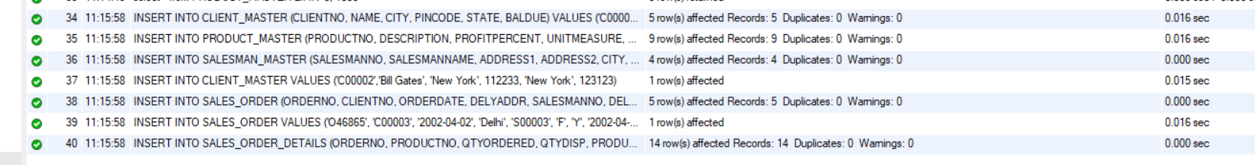

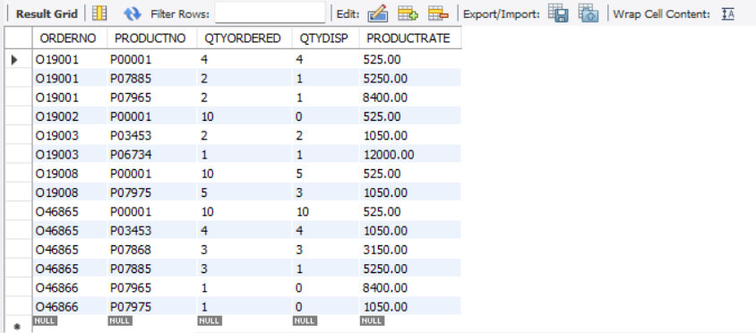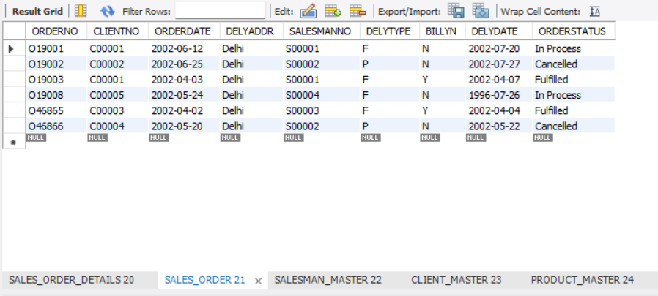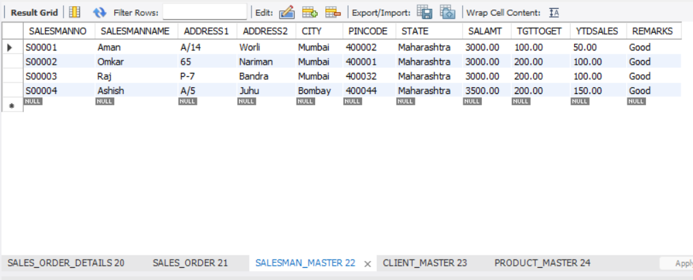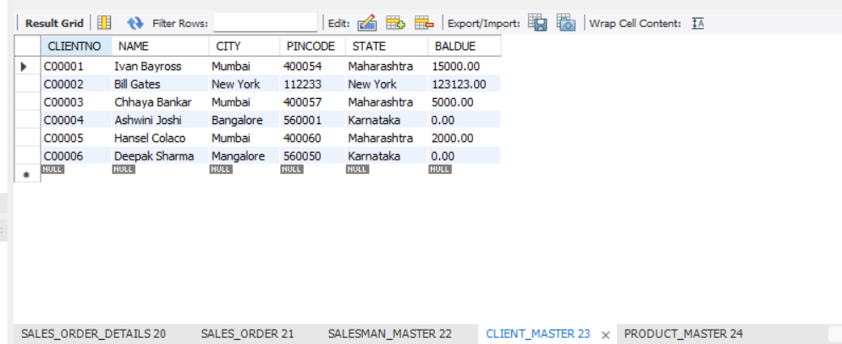

3. Generate the SQL statements to perform the following computations on table data in Python IDLE:
a. List the names of all clients having ‘a’ as the second letter in their names.

SELECT NAME FROM CLIENT_MASTER
WHERE NAME LIKE '_a%';

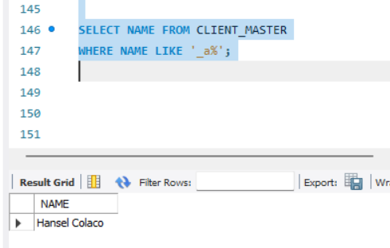
b. List the clients who stay in a city whose first letter is ‘M’.

SELECT * FROM CLIENT_MASTER
WHERE CITY LIKE 'M%';

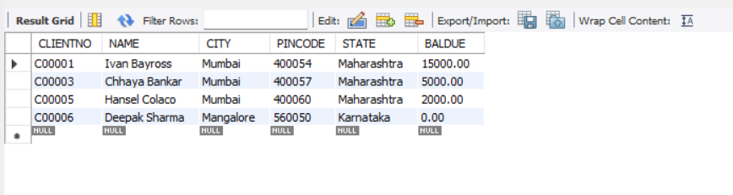
c. List all clients who stay in ‘Bangalore’ or ‘Mangalore’.

SELECT * FROM CLIENT_MASTER
WHERE CITY IN ('Bangalore', 'Mangalore');

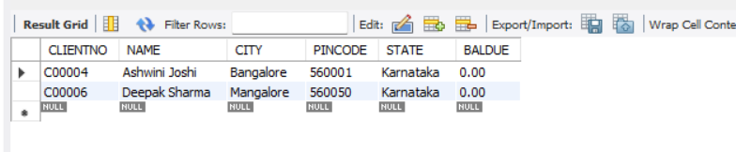
d. List all clients whose BalDue is greater than value 10000.

SELECT * FROM CLIENT_MASTER
WHERE BALDUE > 10000;

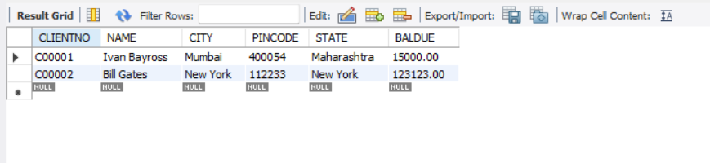

e. List all information from the Sales_order table for order placed in the month of
June.
SELECT * FROM SALES_ORDER
WHERE MONTH(ORDERDATE) = 6;

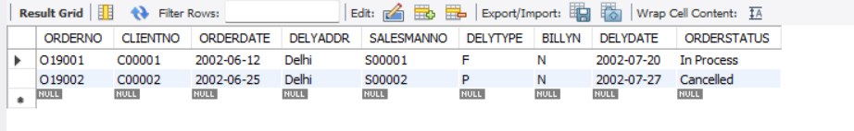

f. List the Order No & day on which clients placed their order.

SELECT ORDERNO, DAY(ORDERDATE) AS OrderDay FROM SALES_ORDER;

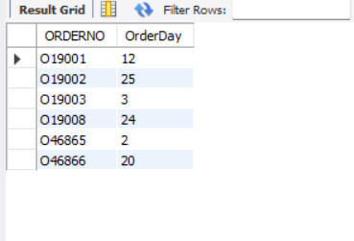
g. List the names, city and state of clients who are not in the state of ‘Maharashtra’.

SELECT NAME, CITY, STATE FROM CLIENT_MASTER
WHERE STATE <> 'Maharashtra';

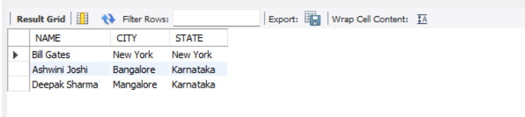

4. Exercises on Using Having, Group By and Joins in Python IDLE:
a. Printing the description and total quantity sold for each product.

import mysql.connector

# Connect to MySQL
conn = mysql.connector.connect(
host="localhost",
user="root",
password="cdac123#",
database="mydb"
)

cursor = conn.cursor()

query_a = """
SELECT P.DESCRIPTION, SUM(SOD.QTYORDERED) AS TotalQuantitySold
FROM PRODUCT_MASTER P
JOIN SALES_ORDER_DETAILS SOD ON P.PRODUCTNO = SOD.PRODUCTNO
GROUP BY P.DESCRIPTION;
"""

cursor.execute(query_a)
rows = cursor.fetchall()

print("Description | Total Quantity Sold")
for row in rows:
print(row[0], "|", row[1])

b. Calculating the average quantity sold for each client that has a maximum order value of 15000.00.

query_b = """
SELECT C.CLIENTNO, C.NAME, AVG(SOD.QTYORDERED) AS AvgQtySold
FROM CLIENT_MASTER C
JOIN SALES_ORDER SO ON C.CLIENTNO = SO.CLIENTNO
JOIN SALES_ORDER_DETAILS SOD ON SO.ORDERNO = SOD.ORDERNO
GROUP BY C.CLIENTNO, C.NAME
HAVING MAX(SOD.QTYORDERED * SOD.PRODUCTRATE) = 15000.00;
"""

cursor.execute(query_b)
rows = cursor.fetchall()

print("\nClientNo | Client Name | Avg Qty Sold")
for row in rows:
print(row[0], "|", row[1], "|", row[2])

